**KALYANI GOVERNMENT ENGINEERING COLLLEGE**

Department of Computer Application



**Programming Concept with Python (MCAN-101) submitted for the fulfilment of CA2, Odd Semester, 2022**

|  |  |
| --- | --- |
| **Name:** | Rajendra Kumar Shaw |
| **Roll No.:** | KGEC/MCA/22/23 |
| **Stream:** | MCA 1st Year 1st Sem |
| **Subject:** | Programming Concept with Python [MCAN-101] |

**Assignment:1**

**1.(a). What are the reasons for python being the first programming language of learners?**

**Answer:**

**Reasons for Using Python as a Beginner:-**

**1. Easy to Learn**

The syntax of various other languages might seem very confusing to you when you just start coding. But, the minimal setup and readability of Python allows you to think like a programmer and saves your time in writing a big syntax format. The syntax of this amazing language is easy and this makes it easier to type and compile. For instance, if you want to build a code that says “Hello World”, it would require you to type around 4 lines in Java, wherein in Python, all you need to write is – print(“Hello World”)

**2. Readily Available Resources to Learn From**

Python is an open-source language, which is free and can be used by anyone. The internet is filled with Python programming courses and tutorials, which provide a broad scope of opportunities for beginners to actually hit and try to narrow down the niche in which they are better than others.

You can actually learn coding skills in just a matter of time. These available resources ensure that you never stop learning new codes and experimenting with your previous ones. This perk of Python catalyze the learning journey for beginners and helps them crave learning for new programs and skills.

**3. The Extensibility Behaviour of Python**

Extensibility in software and languages refers to the ability of the software to extend to include new additions with minimal to no change in the existing code. Simply put, it is the measure of how easily a new behaviour can be added to its existing structure and code. Several programming languages like Tcl and Python, are highly extensible.

Python can be extended to other languages, this doesn’t involve extending the language itself. Python allows writing Python modules in other languages like C, C++, it lets you interface libraries written in different languages. It is also embeddable, which means that you can write a Python code in a source code in different languages like C, C++, or JAVA.

**4. Python is Best Known For Its Versatility**

Python’s versatility helps developers narrow down into their niche and select one or two in which they are most confident. Python is a language that can be used in a range of different environments like web development, data science, game

development, etc. It has many applications. The vast versatility of this language allows developers to choose from a wide range of career options.

You may not have a clear idea of what you want to build in the future when you are new to a programming language. The diversity of Python will surely help beginners to explore more and find their passion quickly.

**5. Python Community Allows You to Learn From the Experts**

Once your learning phase is over, and you start coding on your own, you might come across an obstacle or two. This is where the Python community will support you to learn from your own mistakes and learn from their experts indirectly.

There are plenty of articles and video tutorials available for beginners to avoid mistakes and learn from them. This service by the Python community is best to enhance your knowledge of the programming language. For example, there are communities like Python forums that help Python users through live sessions, webinars, articles, video tutorials, and whatnot! If the coder is facing any issue, they can get instant support from the community, and it is as simple as that.

**1.(b). What are the arithmetic operators in python? Explain with example.**

**Answer:-**

Arithmetic operators are used in python to perform mathematical operations like addition, subtraction, multiplication and division. There are 7 arithmetic operators in Python :

* 1. Addition
  2. Subtraction
  3. Multiplication
  4. Division
  5. Modulus
  6. Exponentiation
  7. Floor division

1. **Addition Operator :** In Python, **+** is the addition operator. It is used to add 2 values.

**Example :**

val1 **=** 10

val2 **=** 3

* using the addition operator res **=** val1 **+** val2 print(res)

**Output :**

13

1. **Subtraction Operator :** In Python, **–** is the subtraction operator. It is used to subtract the second value from the first value.

**Example :**

val1 **=** 10

val2 **=** 3

* using the subtraction operator res **=** val1 **-** val2

print(res)

**Output :**

7

1. **Multiplication Operator :** In Python, **\*** is the multiplication operator. It is used to find the product of 2 values.

**Example :**

val1 **=** 10

val2 **=** 3

* using the multiplication operator res **=** val1 **\*** val2

print(res)

**Output :**

30

1. **Division Operator :** In Python, **/** is the division operator. It is used to find the quotient when first operand is divided by the second.

**Example :**

val1 **=** 10

val2 **=** 3

* using the division operator res **=** val1 **/** val2 print(res)

**Output :**

3.3

1. **Modulus Operator :** In Python, **%** is the modulus operator. It is used to find the remainder when first operand is divided by the second.

**Example :**

val1 **=** 10

val2 **=** 3

* using the modulus operator res **=** val1 **%** val2 print(res)

**Output :**

1

1. **Exponentiation Operator :** In Python, **\*\*** is the exponentiation operator. It is used to raise the first operand to power of second.

**Example :**

val1 **=** 10

val2 **=** 3

* using the exponentiation operator res **=** val1 **\*\*** val2

print(res)

**Output :**

1000

1. **Floor division :** In Python, **//** is used to conduct the floor division. It is used to find the floor of the quotient when first operand is divided by the second.

**Example :**

val1 **=** 10

val2 **=** 3

* using the floor division res **=** val1 **//** val2 print(res)

**Output :**

3

Below is the summary of all the 7 operators :

|  |  |  |
| --- | --- | --- |
| Operator | Description | Syntax |
| + | Addition: adds two operands | x + y |
| – | Subtraction: subtracts two operands | x – y |
| * | Multiplication: multiplies two operands | x * y |
| / | Division (float): divides the first operand by the second | x / y |
| // | Division (floor): divides the first operand by the second | x // y |
| % | Modulus: returns the remainder when first operand is | x % y |
|  | divided by the second |  |
| ** | Power : Returns first raised to power second | x ** y |

**1.(c) What are the role of indentation in python? Provide example to support your answer.**

**Answer:-**

**Python Indentation**

Indentation refers to the spaces at the beginning of a code line. In other programming languages the indentation in code is for readability only, the indentation in Python is very important.

Python uses indentation to indicate a block of code just like in c,c++ we use curly braces {}to indicate a block .

**EXAMPLE:**

**Without Indentation:-**

The above code will give the following error:-

"""

Created on Sun Nov 20 20:07:08 2022

@author: Rajendra

"""

name = 'Rajendra Kumar Shaw'

if name == 'Rajendra Kumar Shaw':

print('Welcome',name)

else:

print("You are not Rajendra")

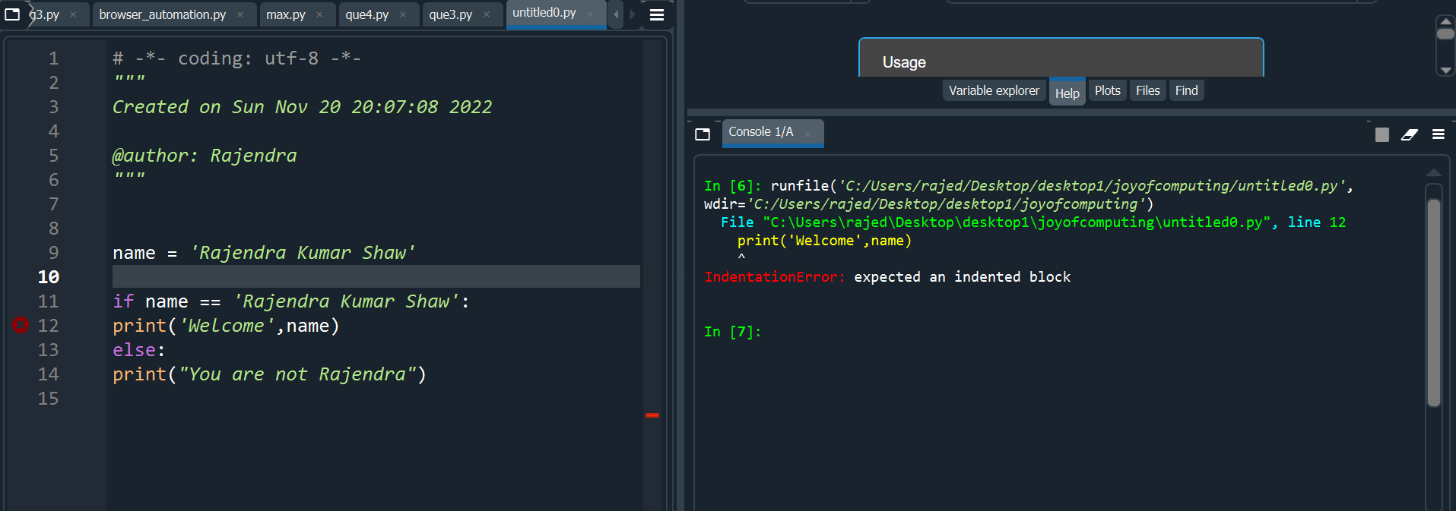

**With Indentation:-**

"""

Created on Sun Nov 20 20:07:08 2022

@author: Rajendra

"""

name = 'Rajendra Kumar Shaw'

if name == 'Rajendra Kumar Shaw':

print('Welcome',name)

else:

print("You are not Rajendra")

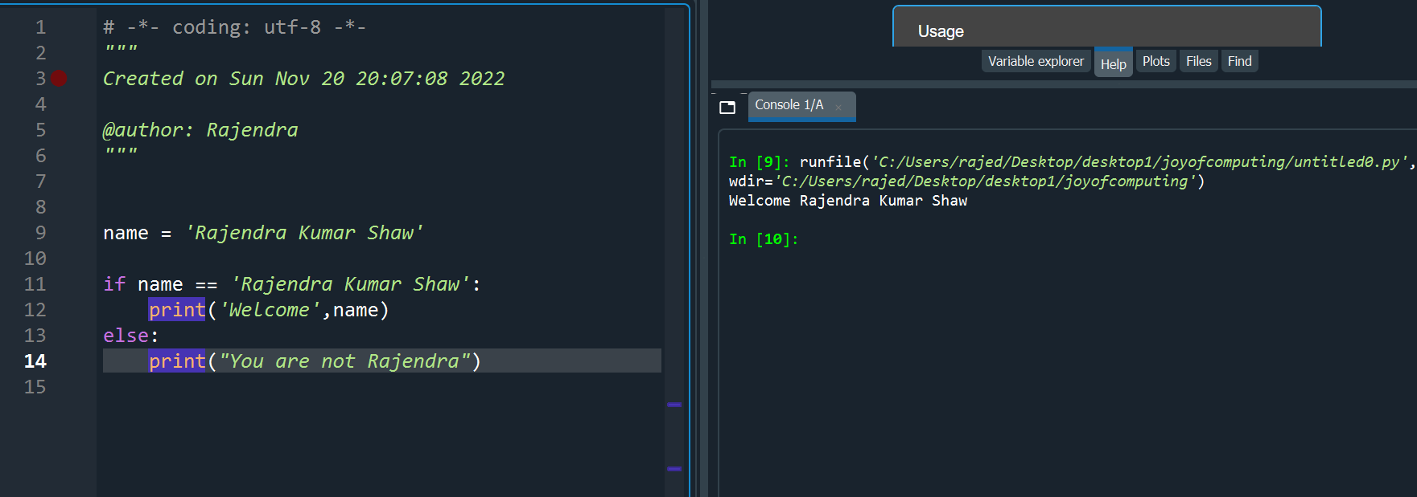

2.(a) **Write a python program to calculate the area of rectangle and circle and print the result. Take input from user (length, breadth and radius).**

Sol:

Code:-

"""

Created on Sun Nov 20 20:07:08 2022

@author: Rajendra

"""

length = float(input("Enter Length of rectangle: "))

breadth = float(input("Enter Breadth of rectangle: "))

print("Area of rectangle is ",length*breadth)

radius = float(input("Enter Radius of Circle: "))

print("Area of Circle is", 2*(22/7)*radius)

Output:-

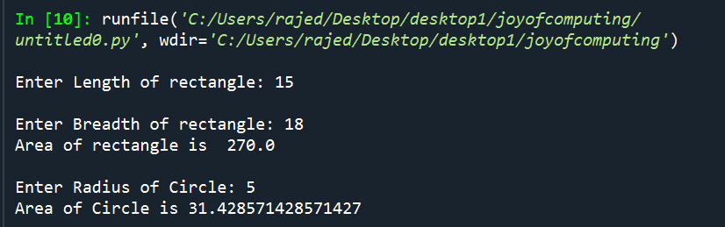

2.(b) **Write a python program to swap two numbers without temporary variable.**

Answer: -

Code:-

a,b = map(int, input().split())

print(f'Before Swapping \nA={a} B={b}')

a,b = b,a

print(f'After Swapping \nA={a} B={b}')

output:-

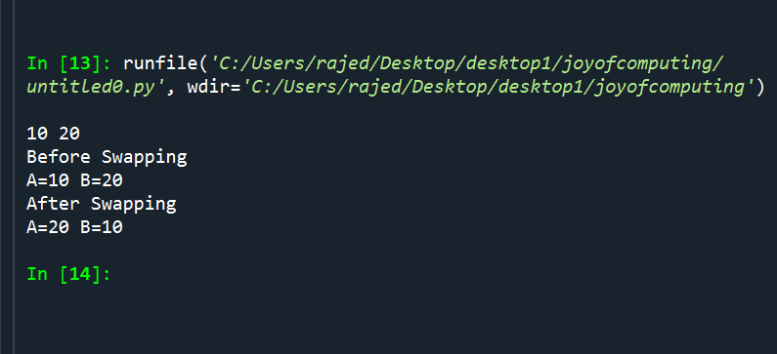

2.(c) **Explain if-elif condition. When do we use it? Explain with example.**

if-elif Statement

The if-elif statement is shortcut of nested if-else. While using if-elif statement at the end else block is added which is performed if none of the above if-elif statement is true.

**Syntax**:-

if (condition):

statement

elif (condition):

statement

.

.

.

else:

statement

**Flow Chart:-**

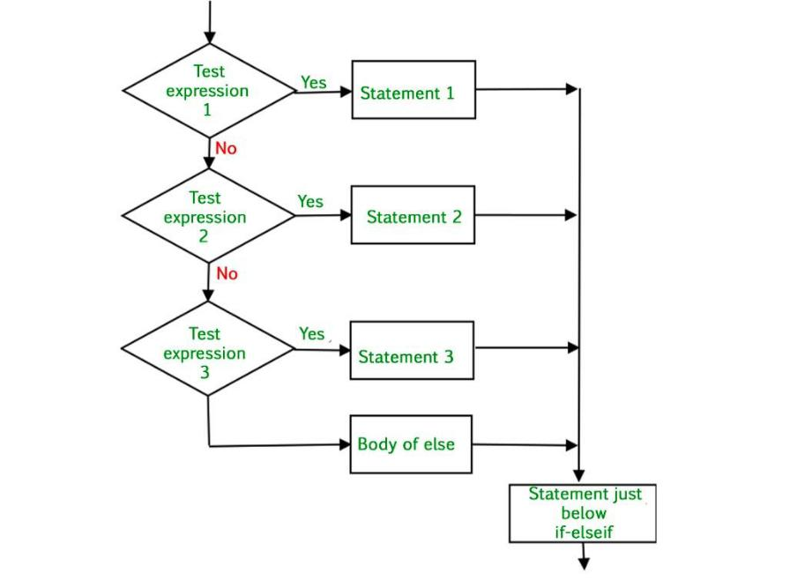

**Example:-**

Code:

a,b,c=map(int,input("Enter three numbers: ").split())

if(a>b and a>c):

print(a,"is the biggest no")

elif(b>a and b>a):

print(b,"is the biggest no")

elif(c>a and c>b):

print(c,"is the biggest no")

else:

print("All are equal")

output:

